

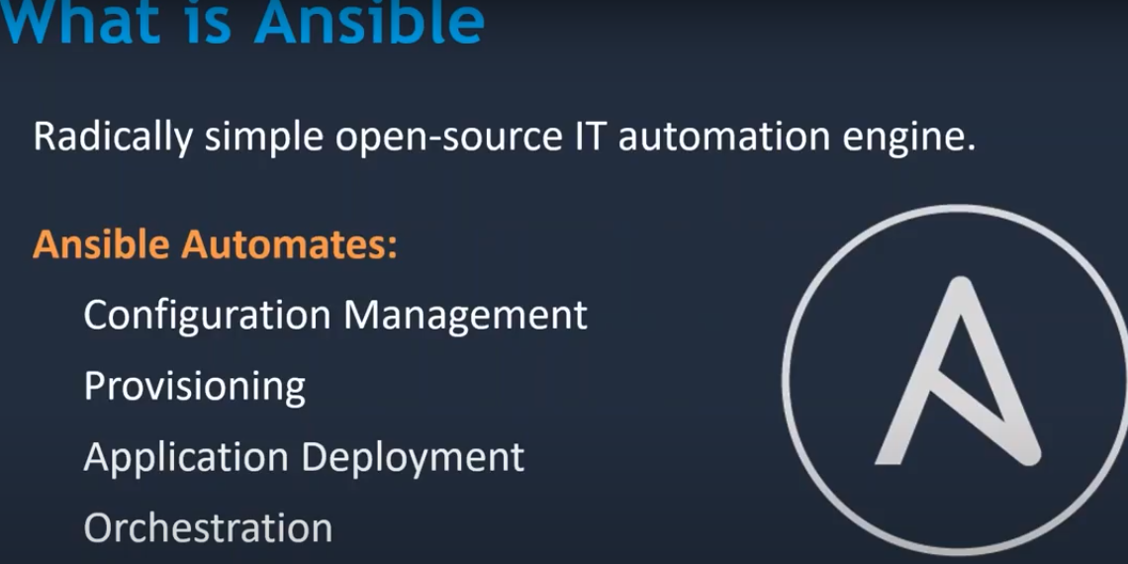

It isa very simple and written in python





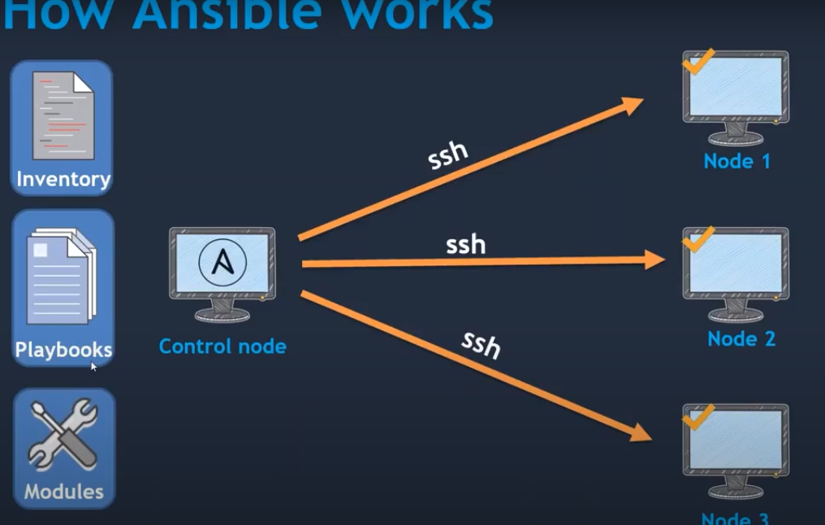

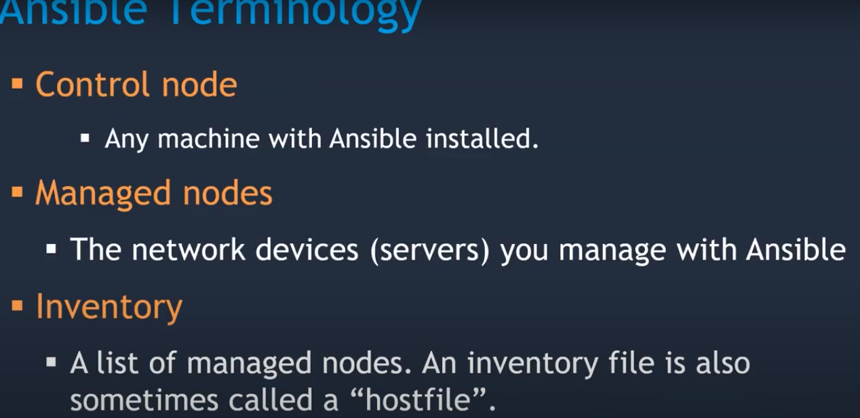

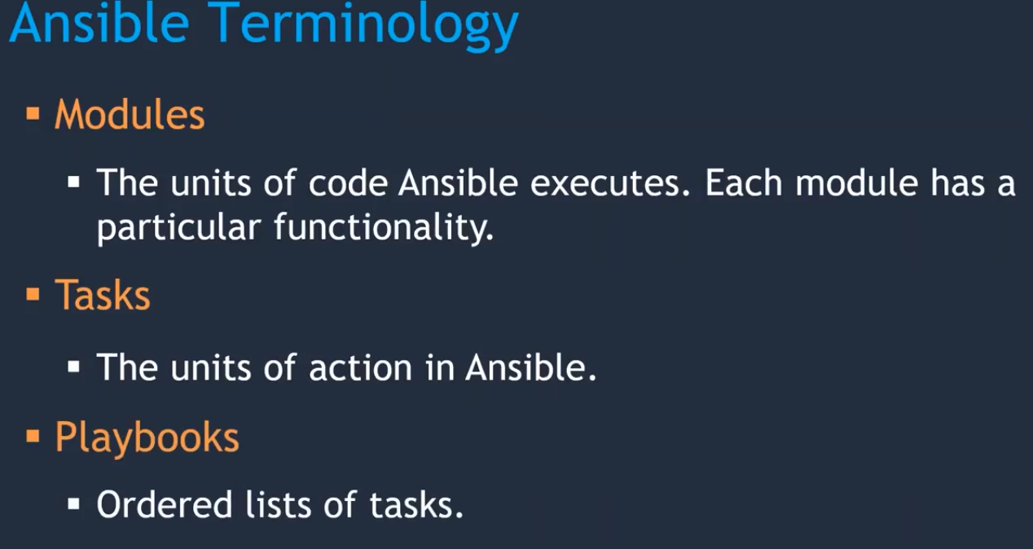

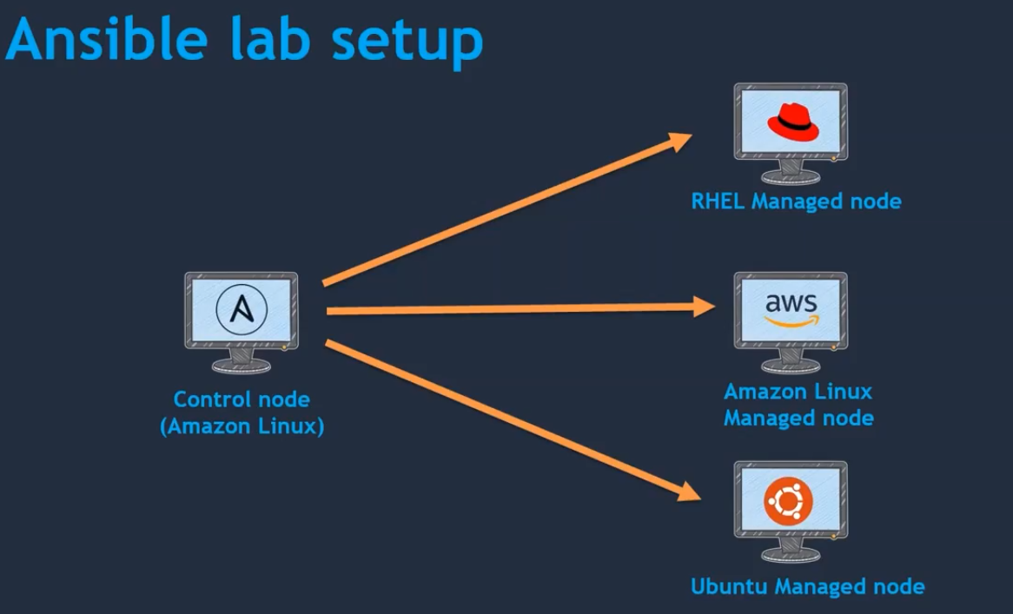

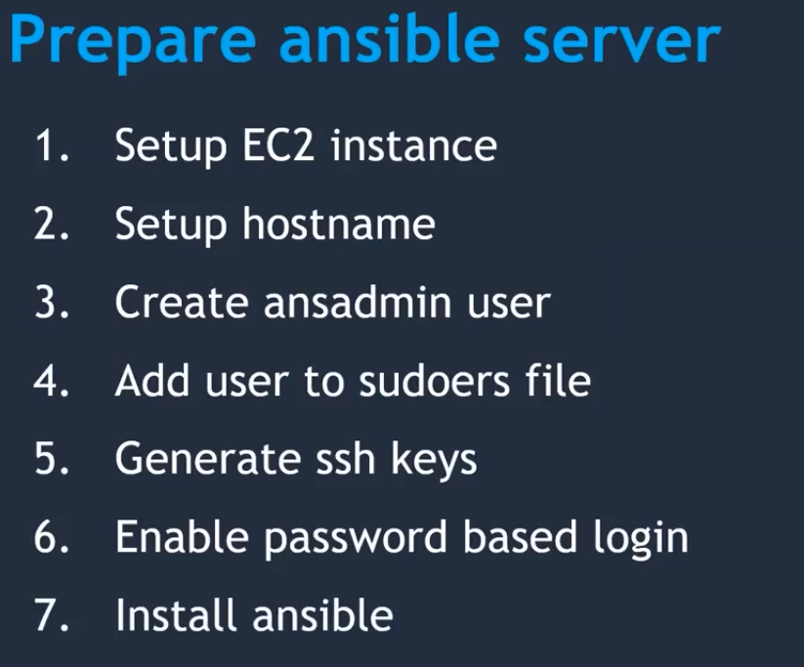

Visudo

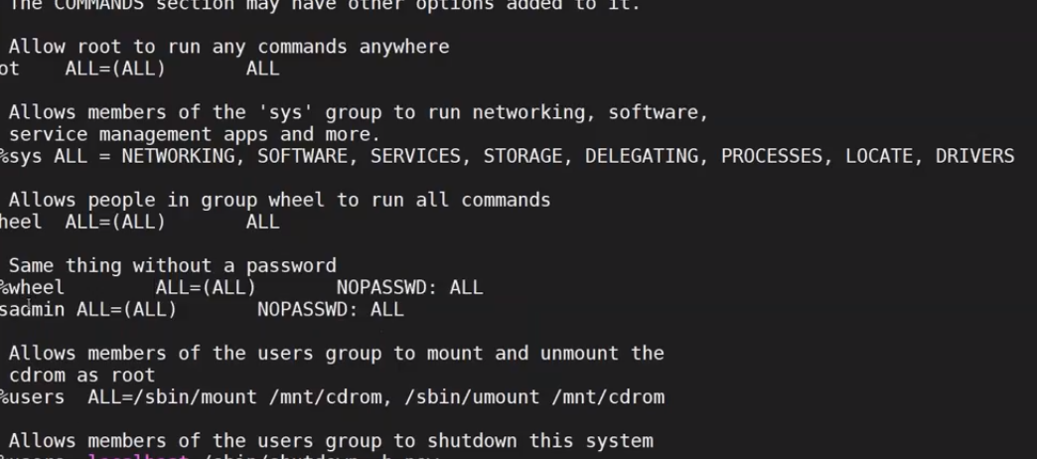

Su – ansadmin

Vi /etc/ssh/sshd_config

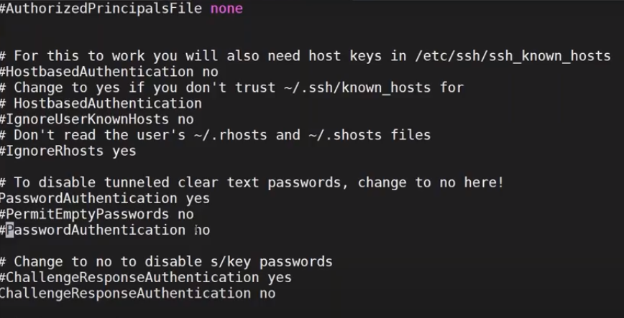

Service sshd start

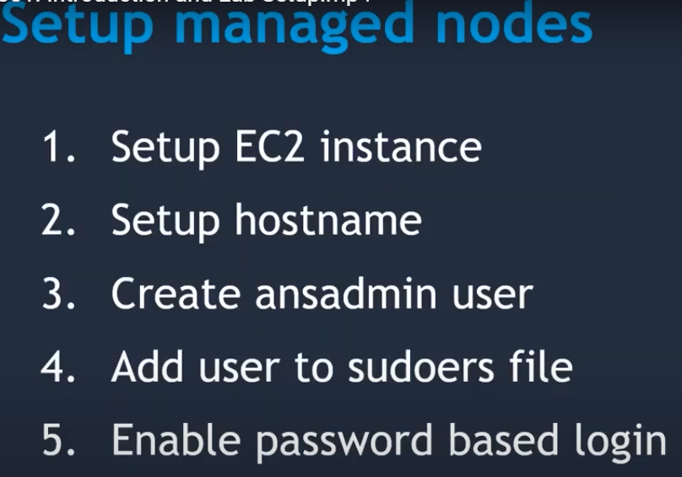

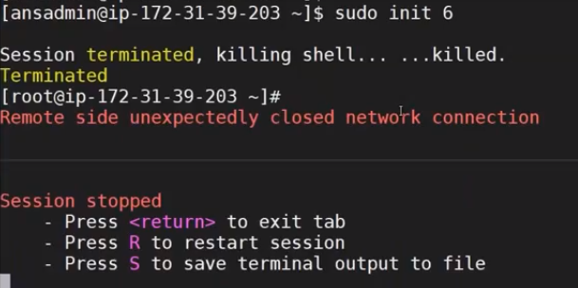

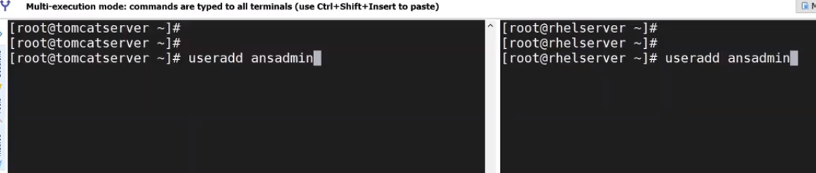



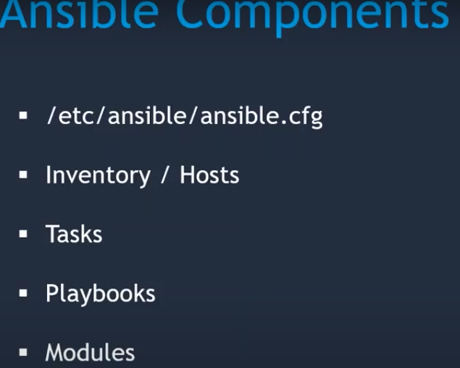

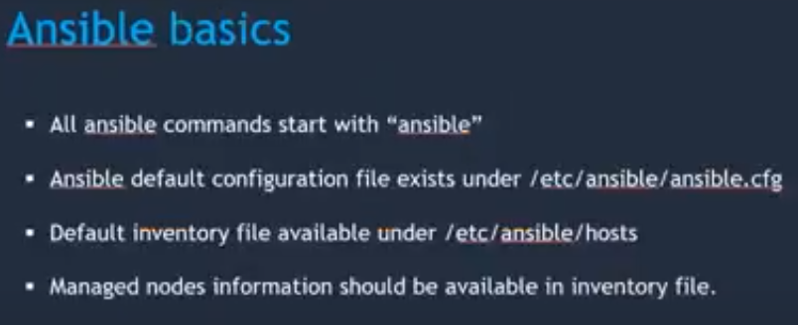

Adhoc commands

Ad-hoc commands are nothing but whenever you have task which you don’ t want to exicute repeatedly

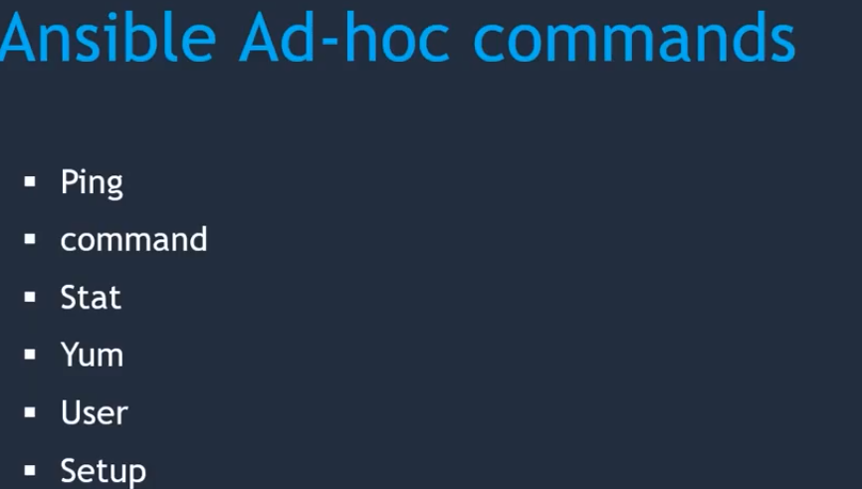

Ansible all –m ping------------🡪ping is a module which gives the information regarding servers which are connected to ACM

Ansible all –m command –a “uptime”----🡪command is a module which helps as linux command execute as it is

Ansible all –m command –a “ls -l”

Ansible all –m command –a “touch test file”

Stat is a command is used for the target system has particular file or not

Ansible all –m command –a stat /home/ansible/testfile--🡪it will give statistics of the servers

Yum : it is one of the module which will use for install the packages on target systems

Ansible all –m yum –a “name = git”

Ansible all –m yum –a “name = git” –b-----------🡪b is nothing but become root user

Ip addr gives the i[address of our system

Yum list installed | grep git

Ansible all –m yum –a “name = tree –b

User: is a module it will helps us to create a user

Ansible all –m user –a “name = ram” it will gives the error because it does’t have root permissions

Ansible all –m user –a “name = ram” –b

We can check it in “cat /etc/passwd”

Setup is a module it will gather the information regarding clients

Ansible all –m setup

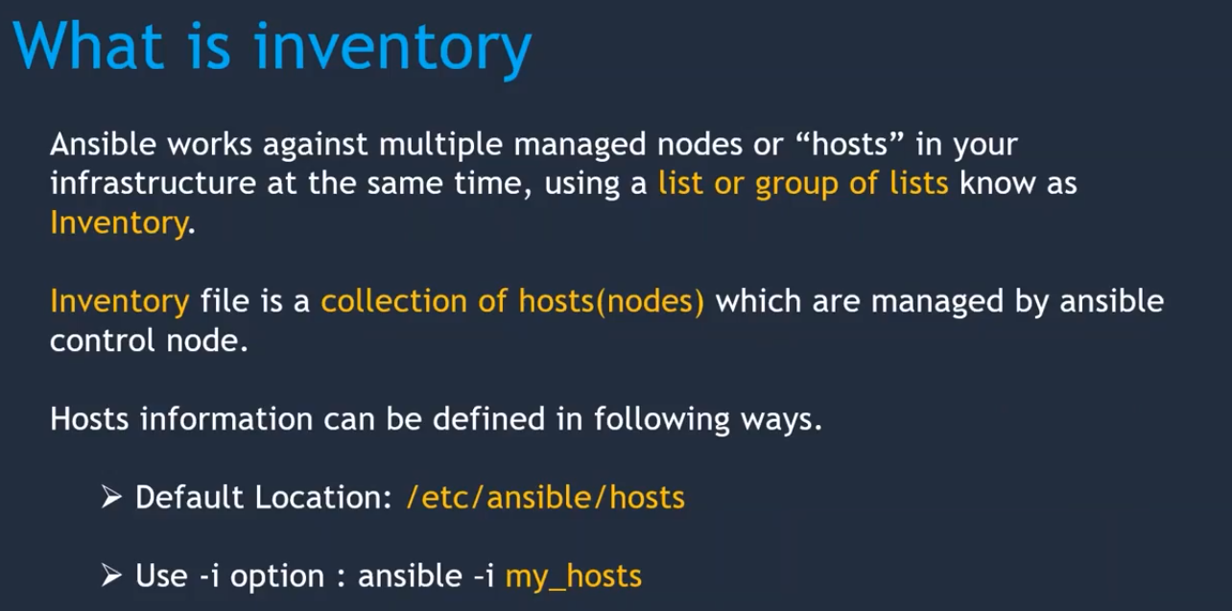

I want to execute one operation in one my servers then we are enter the ip address in inventory file or create our own inventory file

i.e.

vi inventory.ini

give the private ip address

Ansible all –I /home/ansible/inventory.ini –m user –a “name = ram” –b

Ansible all –m command –a “uptime”

Ansible all –m –a “uptime” -🡪it will gives the information like above command

Ansible all –a “name = git”-🡪it will gives the error ,because inventory file not have the information of yum module.if we uncomment in /etc/ansinle/ansible.cfg, it will execute

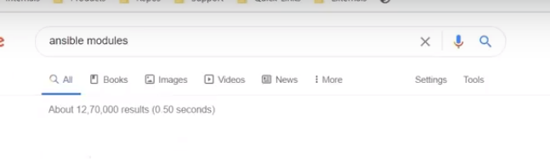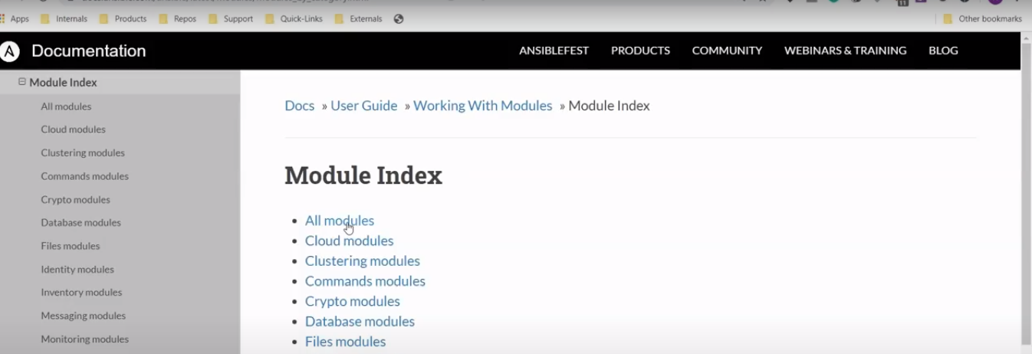

Vi shortcuts

Shift+g-----------------------🡪it will take the end of the file

Shift+a-------------------🡪it will take you to the end of the line

Esc+set nu -------------------🡪it will give the serial no to the lines

Esc+/whatever youwant to search here you can type here-🡪enter ==🡺it will give your search word--🡪presds ‘n’ for next

O ---------------🡪 it will take you to the above line,where ever you are here

o------------------🡪 it will take you to the next line,where ever you are here

d----------------------🡪it will delete entire line

x ------------🡪removes the charercters

r-------------------🡪replace the single character

u ----------------🡪it will give undo the changes

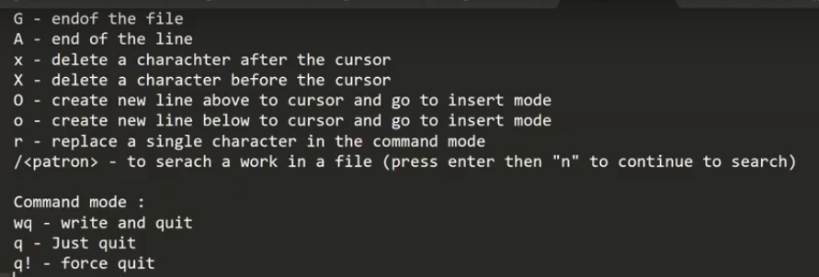

Nano editor

Ctrl+o------------------🡪write out

Crl+w ------------------🡪search

Ctrl+k ----------🡪cut text

Ctrl+x----------🡪exit

Ctr`l+o,yes,ctrl+x

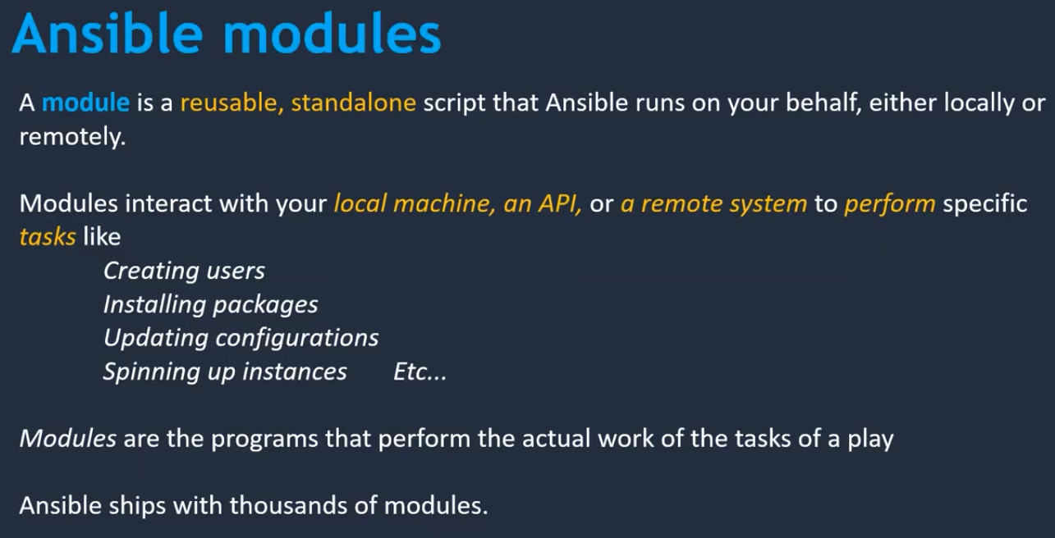

If you create a user you can check it in target machines by using thbe command is

Cat /etc/passwd

Ansible all –m user –a “name=john” –b

Ansible all –m yum –a “name=telnet” –b

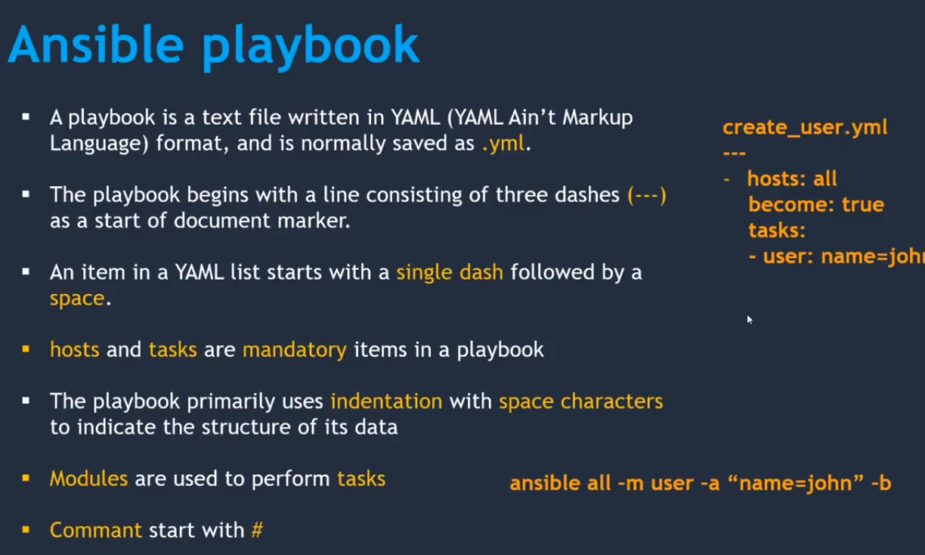

Adhoc command convert into aplaybook

Ansible all –m user –a “name=user” –b

----

* Hosts:all

Become = true

Tasks:

- user:name=john

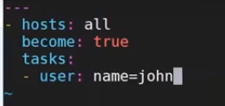

Execution of ansible playbook

Ansible-playbook playbook name

To check hosts following command is used

Ansible all –list-hosts

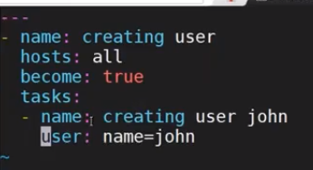

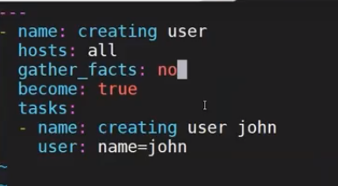

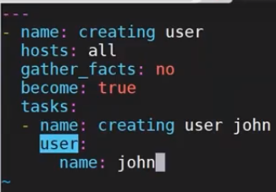

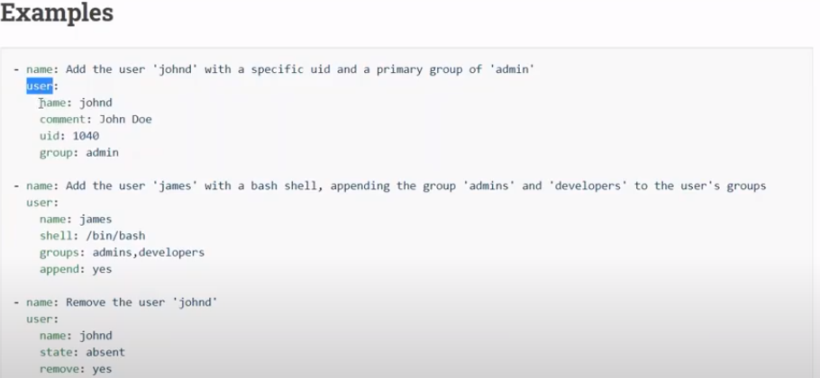

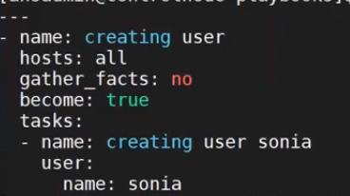

Playbook for to install packages:

Vi install package.yaml

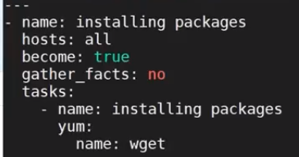

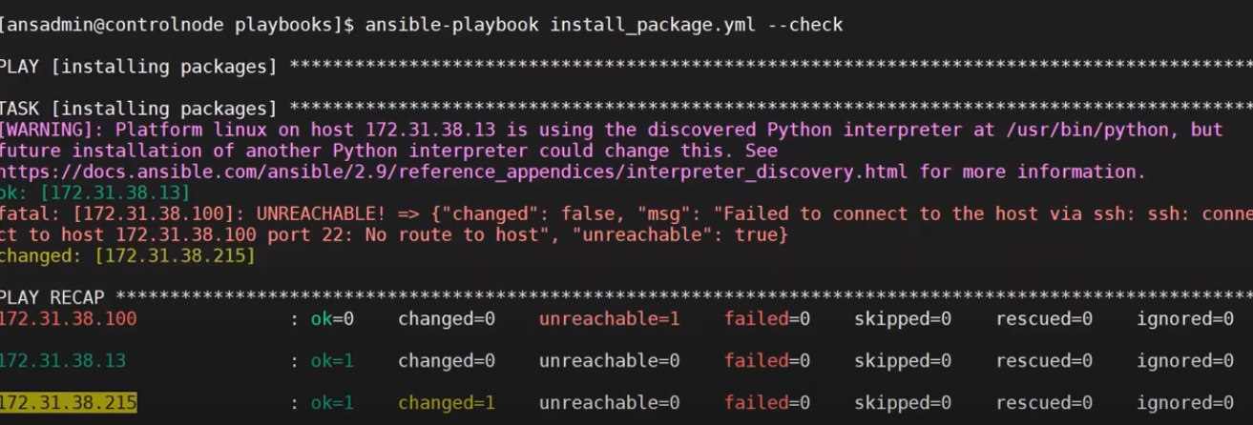

<https://docs.ansible.com/ansible/latest/module_plugin_guide/index.html>

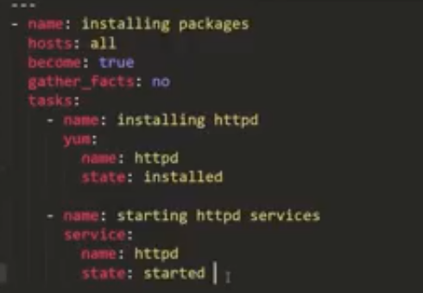

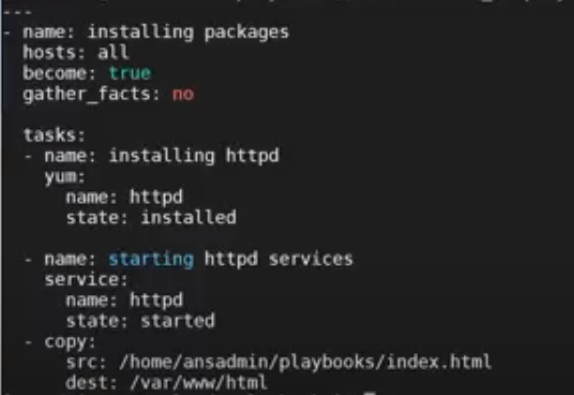

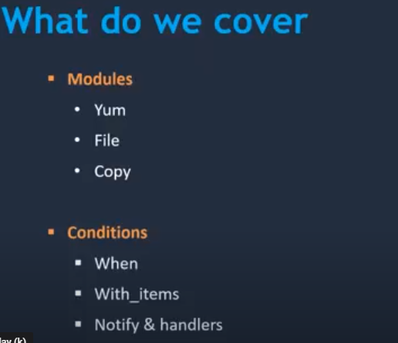

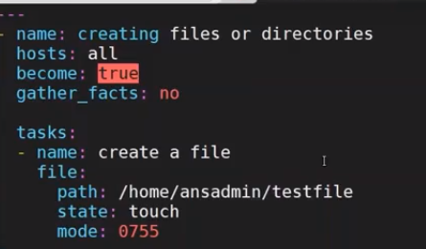

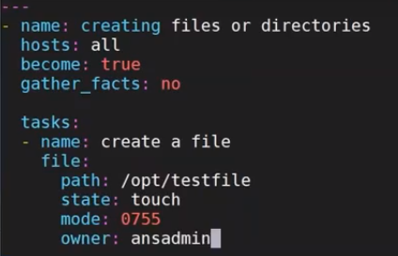

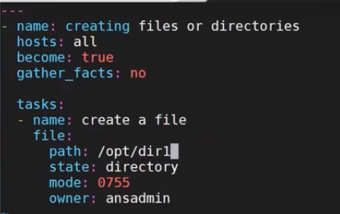

Vi packages_install.yaml

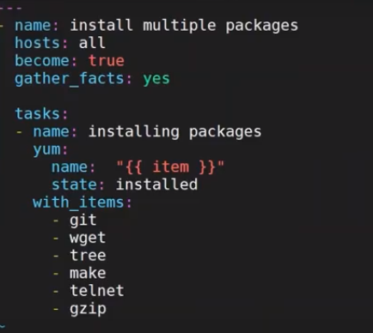

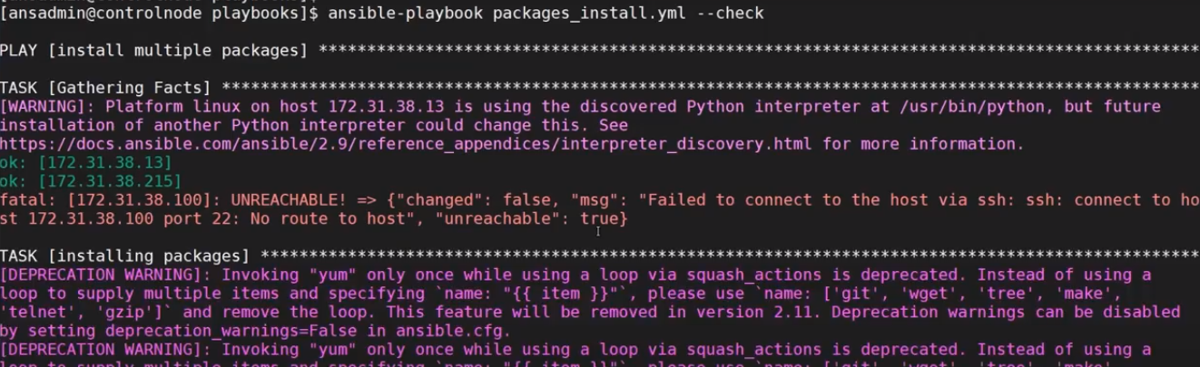

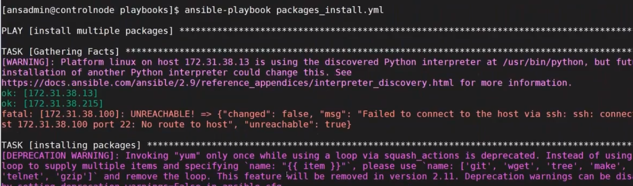

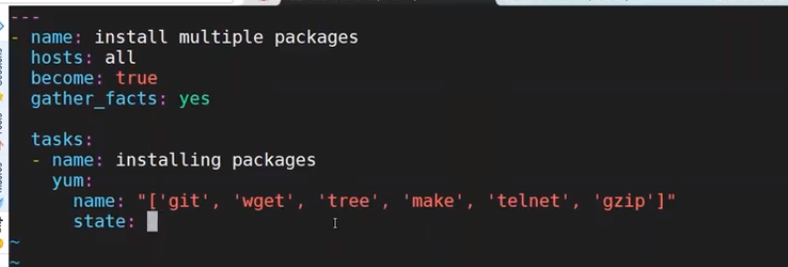

To remove we can use following

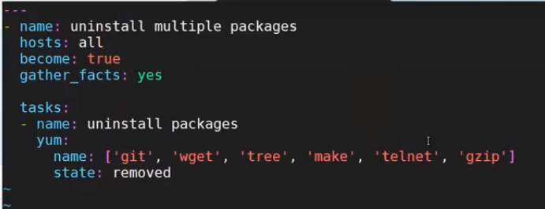

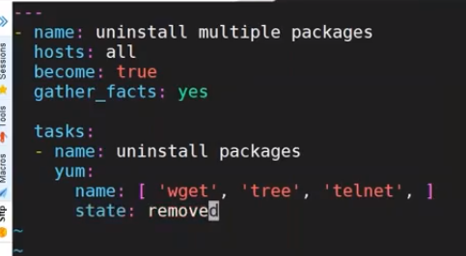

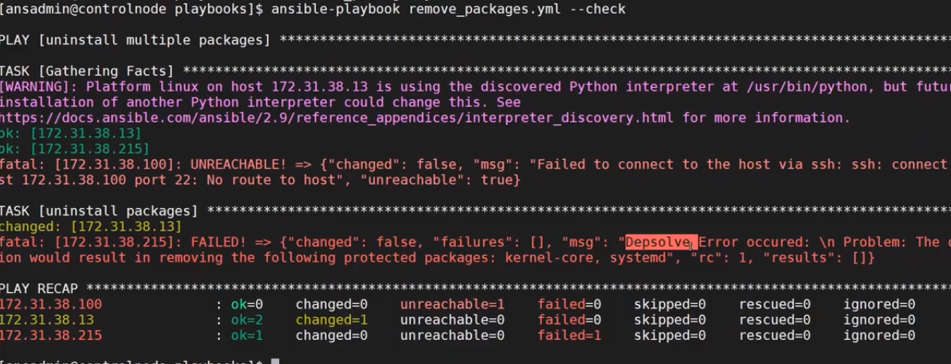

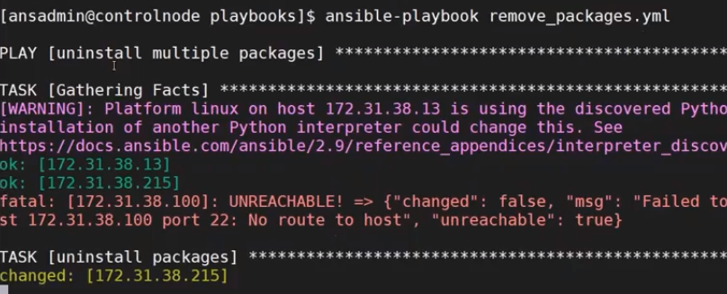

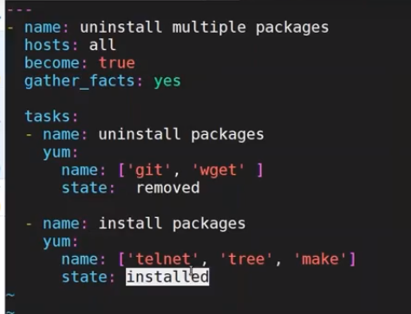

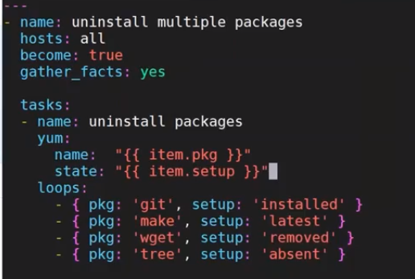

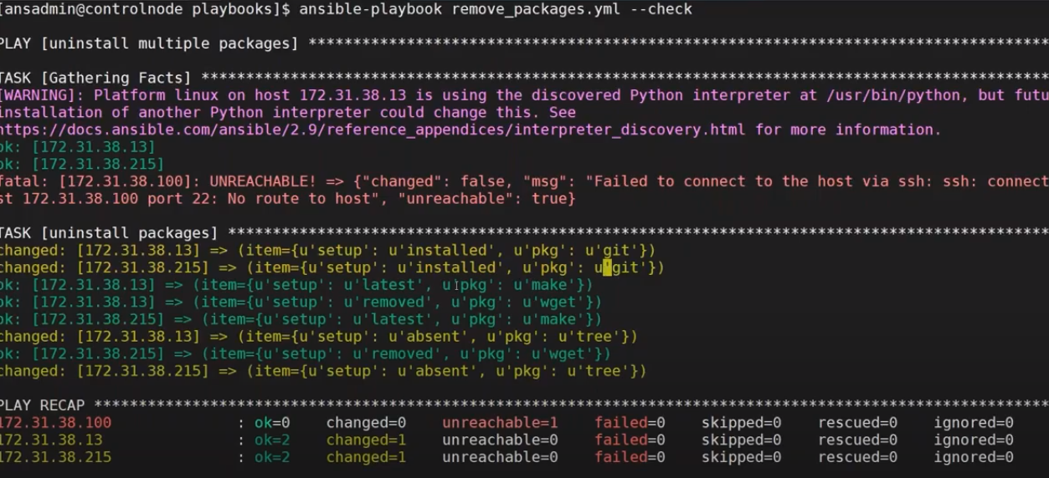

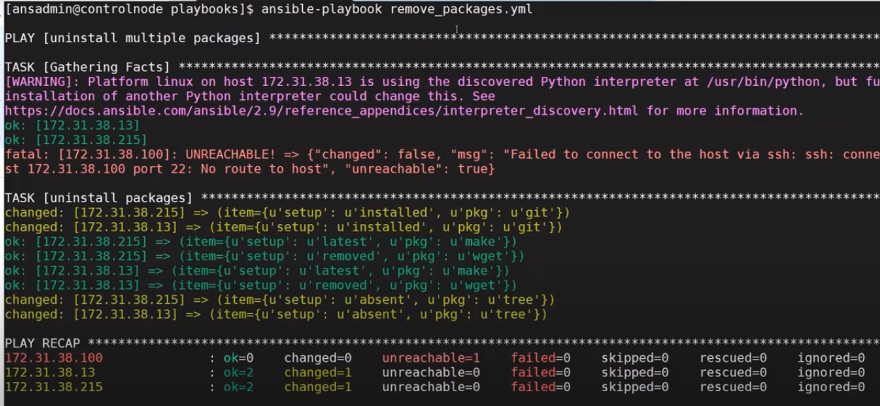

Launch and add the Ubuntu server to ansible

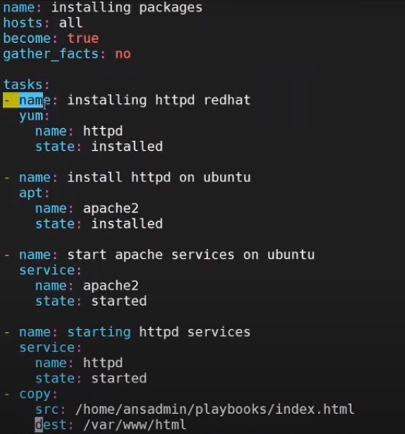

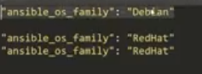

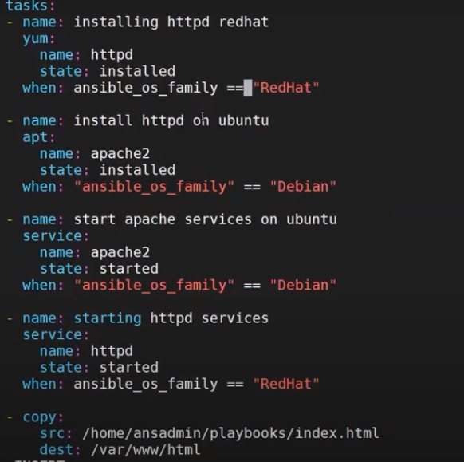

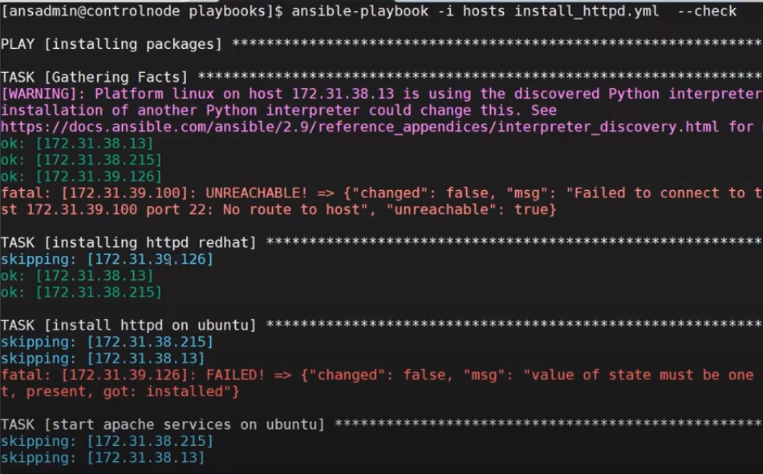

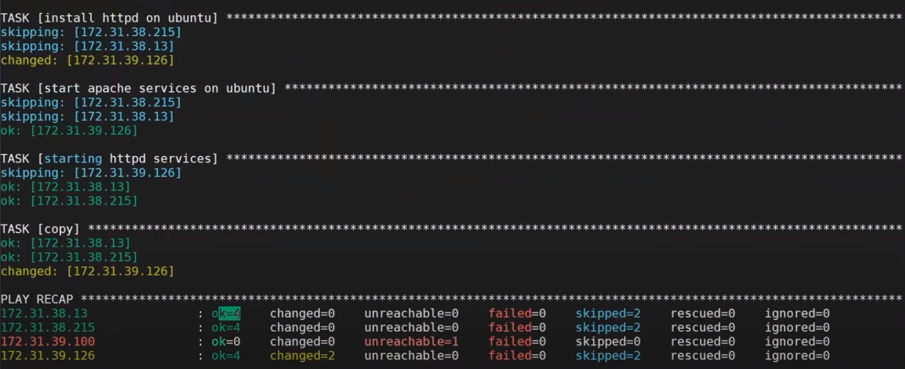

Now we have to take the public ip of Ubuntu server and enter it in to the browser and get the htpd out put

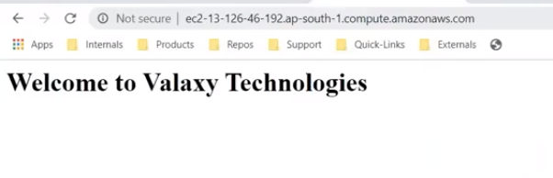

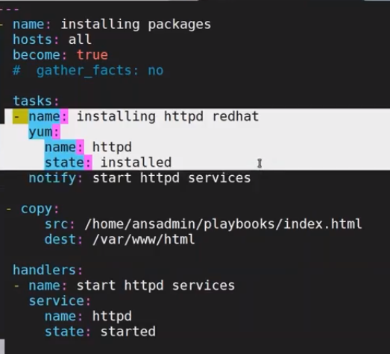

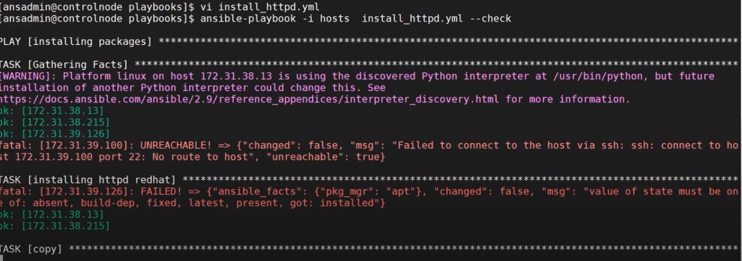





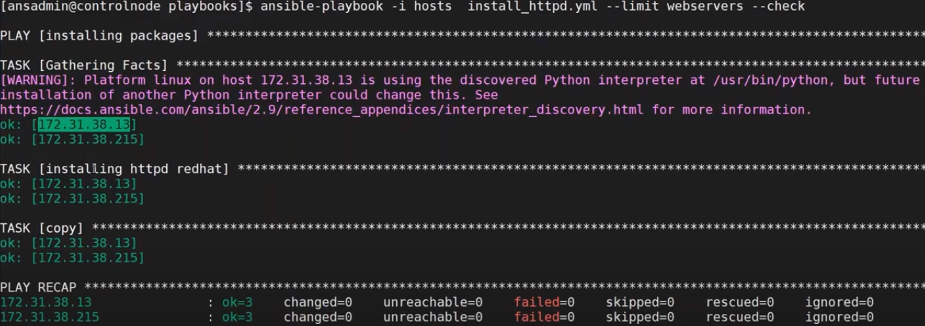

Vi remove_httpd.yml

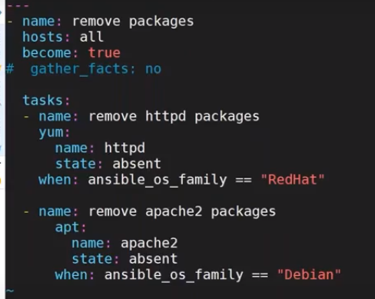

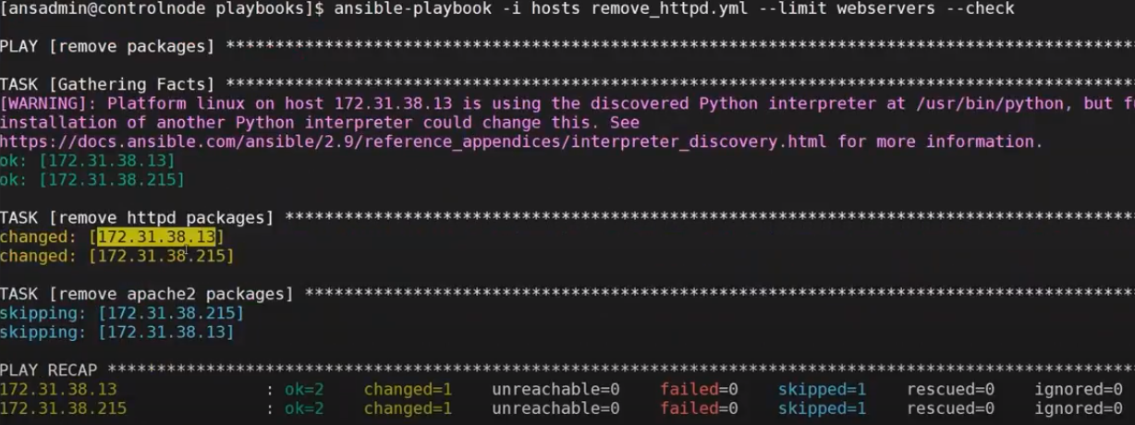

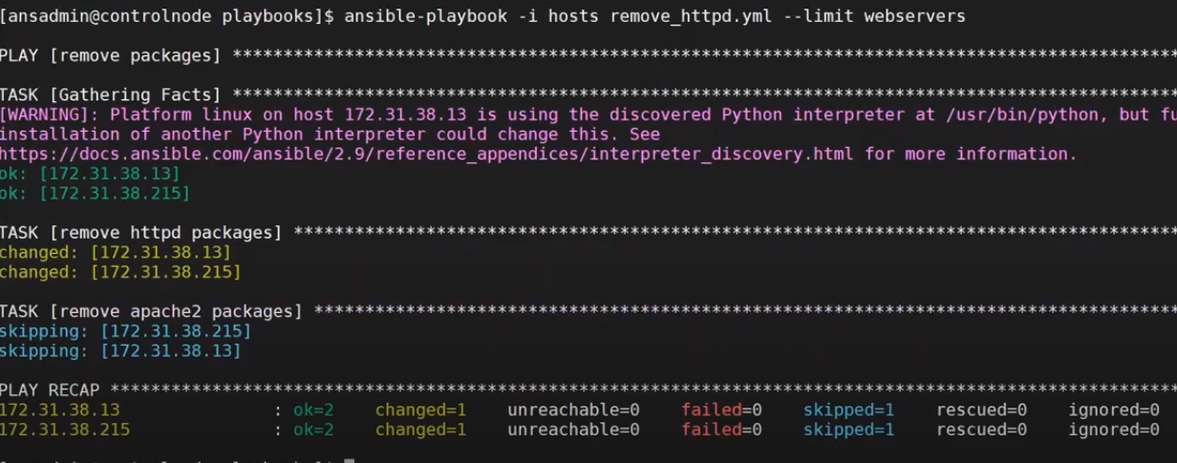

At this time first we remove thehttpd on three systems by using adhoc commands now we have to reinstall httpd on servers

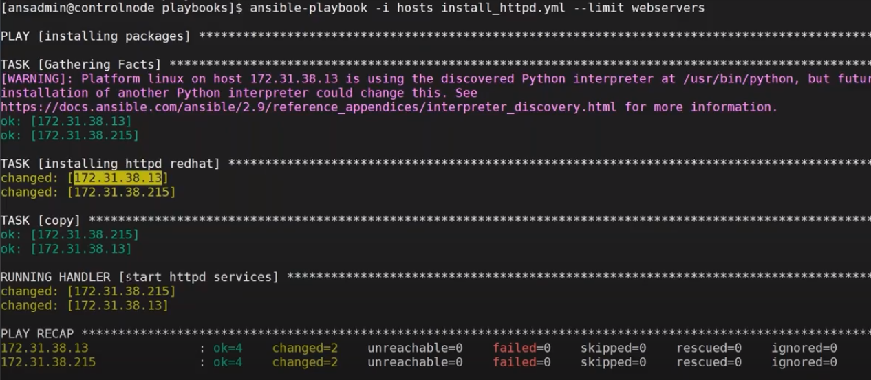

Now I want to install git using playbook

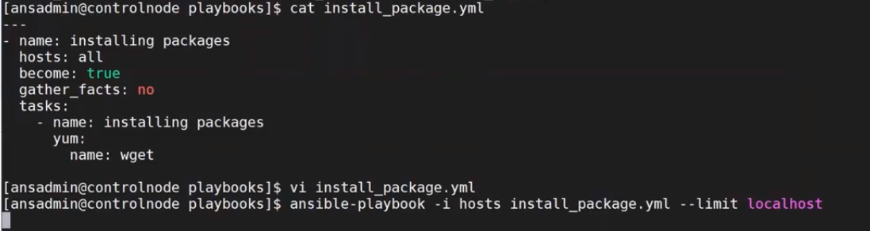

**Git hub url of valaxy technologies**

<https://github.com/ravdy/ansible>



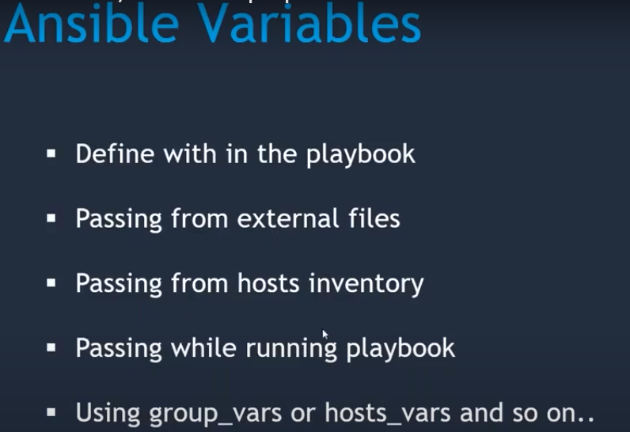

<https://docs.ansible.com/ansible/latest/playbook_guide/playbooks_variables.html#:~:text=Ansible%20uses%20variables%20to%20manage,syntax%2C%20including%20lists%20and%20dictionaries>.

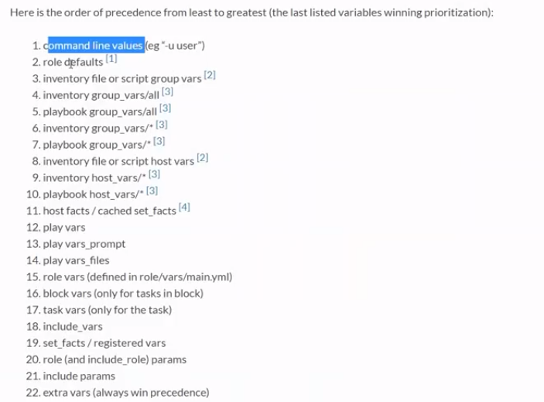

Vi create_user.yaml

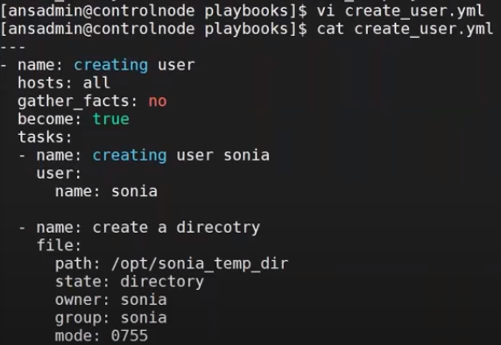



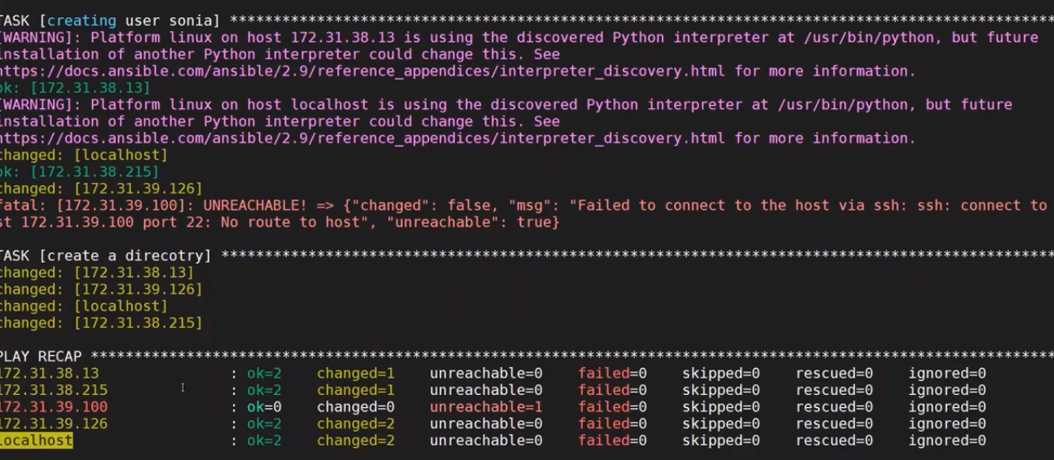 ;

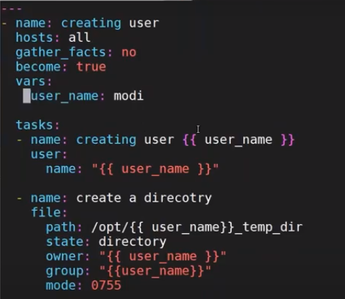

Now I want to give variables in external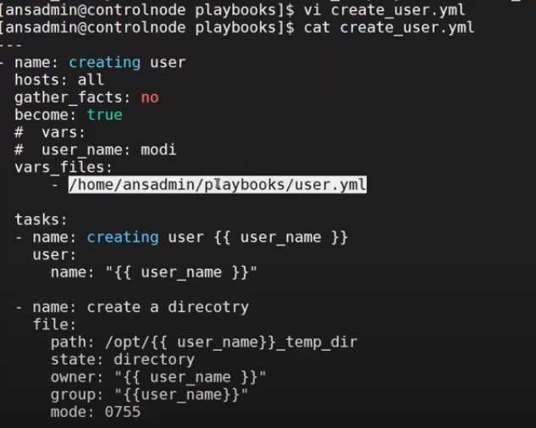

Vi user.yaml

User_name:ramu

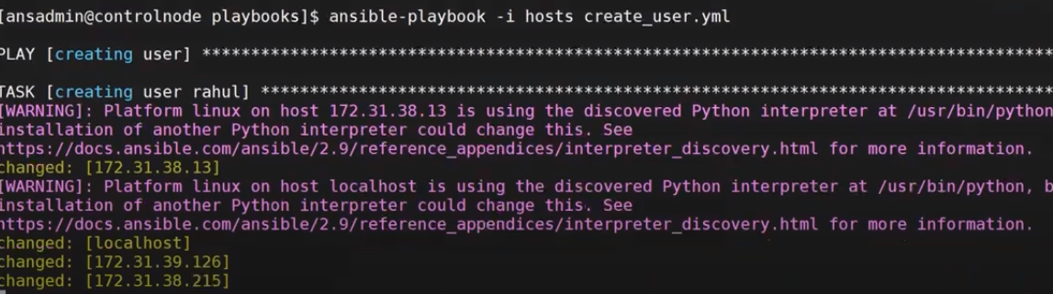

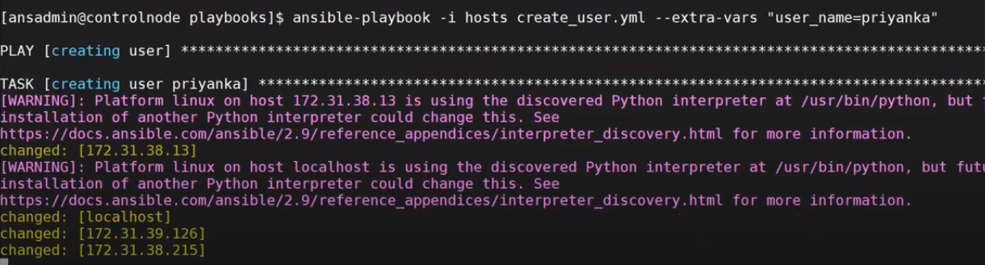



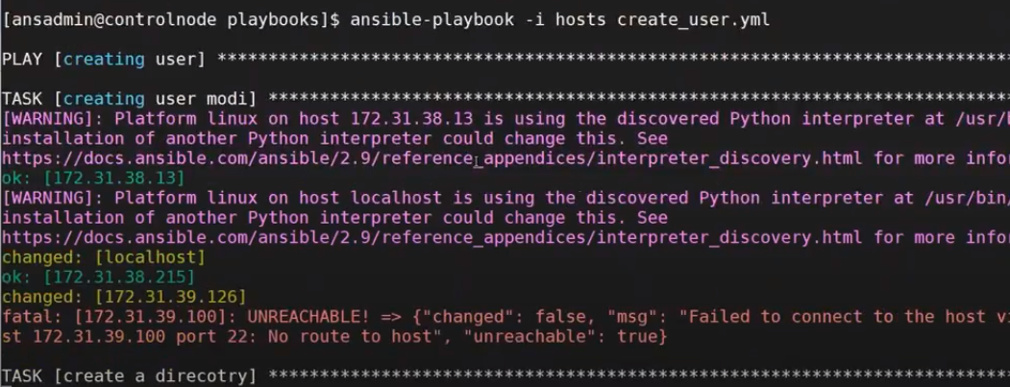

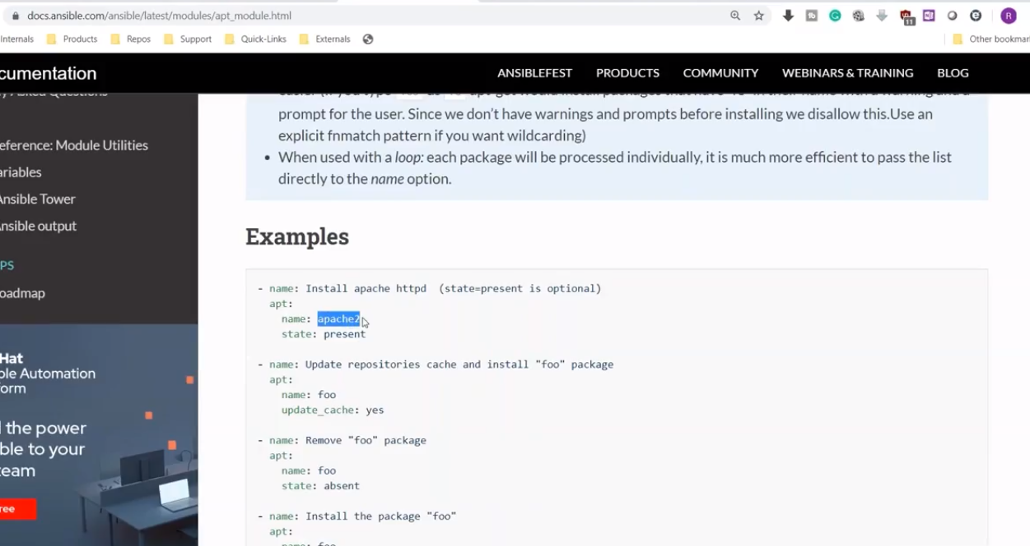

Vi tomcat_setup.yml

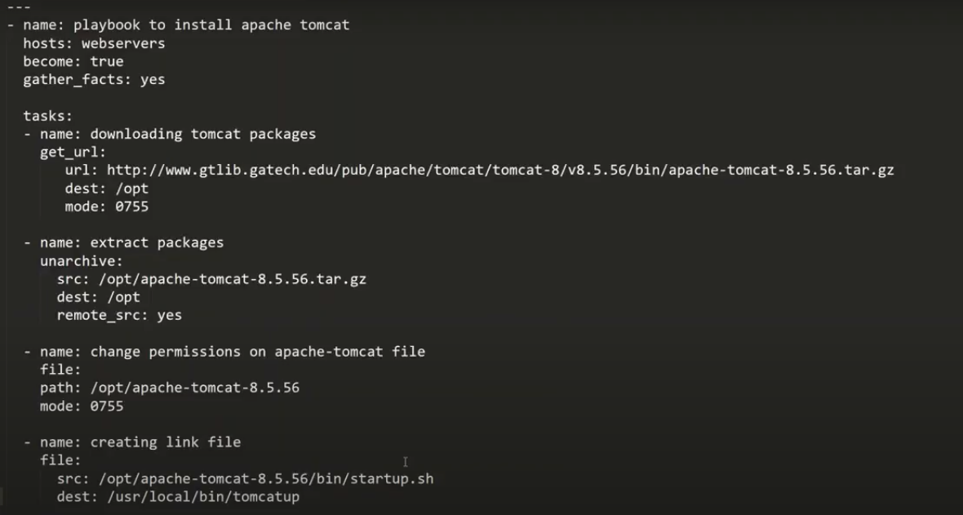

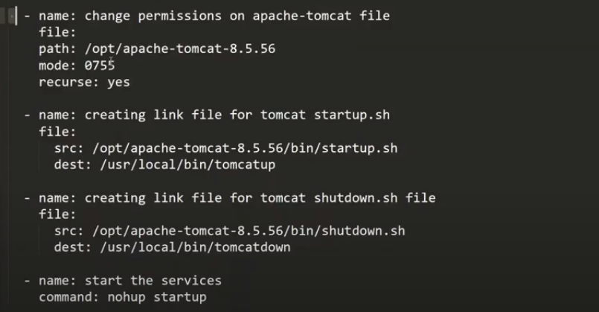

To start the tomcat we have to create symbolic link

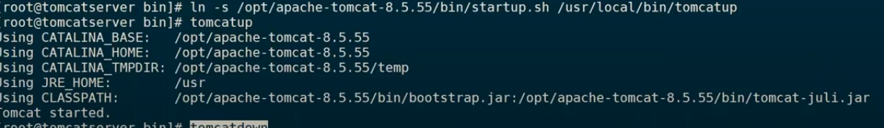

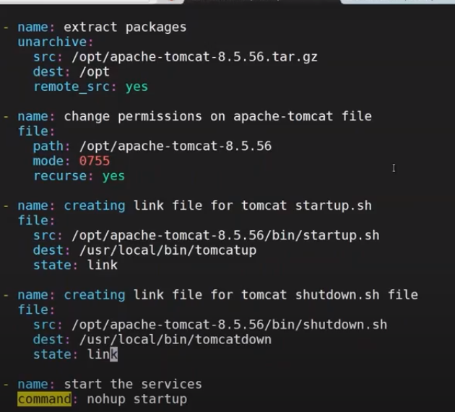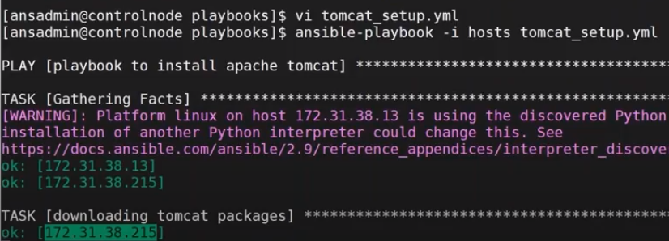

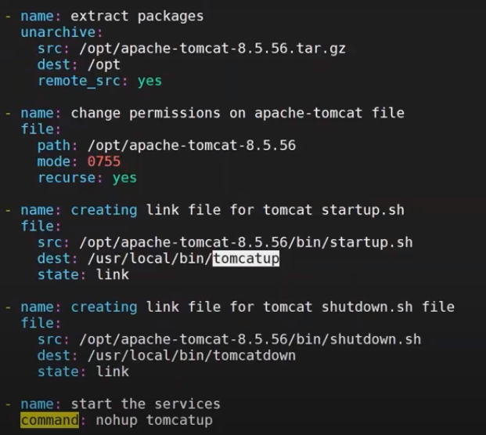

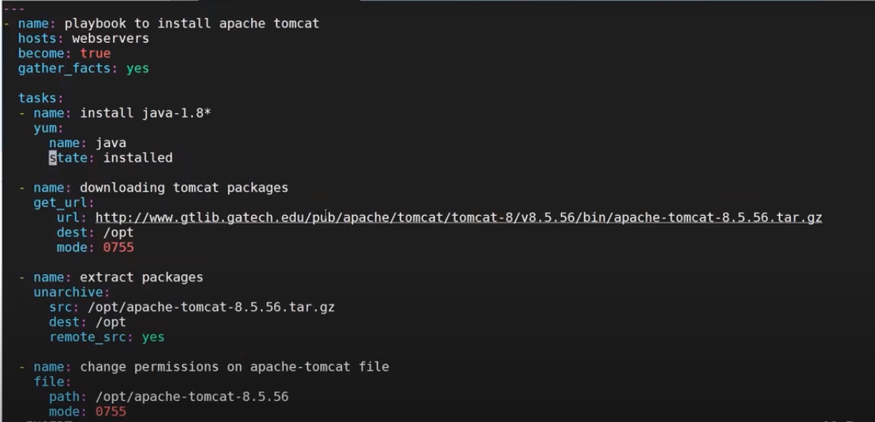

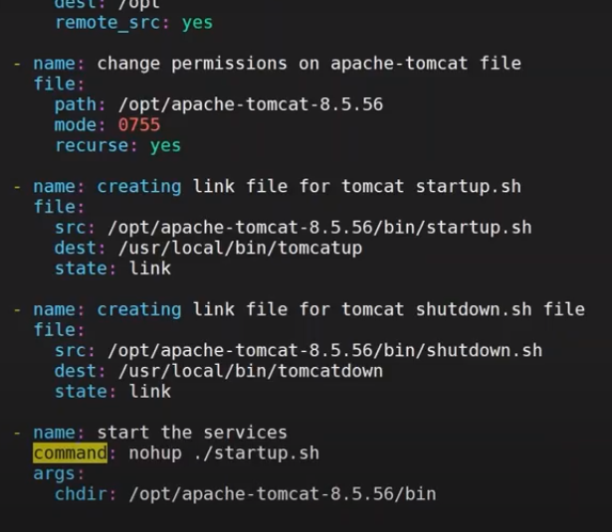

To ckeck the tomcat server go to server terminal and enter the following command

Ps –ef | grep tomcat

now take the public url of the server and enter it in browser and we get tomcat home page

using variables we can rewrite the ansible playbook

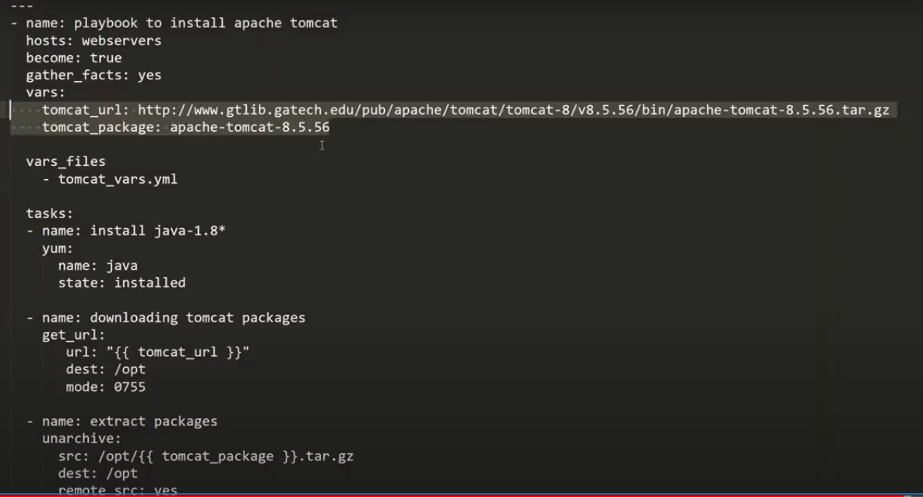vi tomcat.var





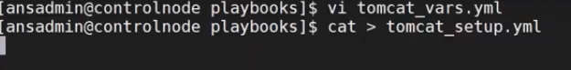

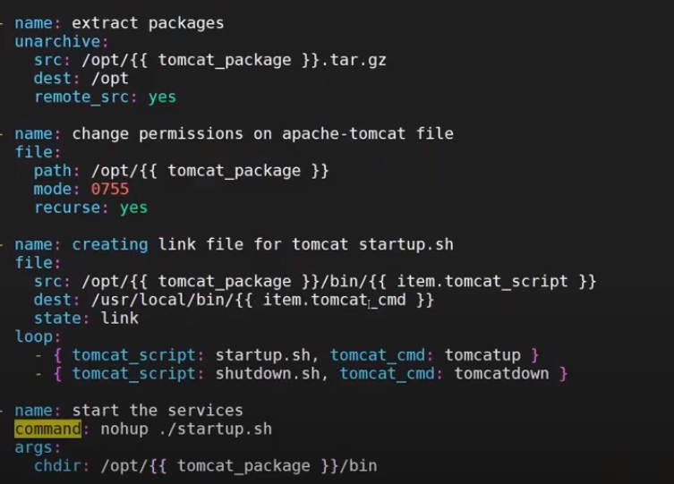

Class-6

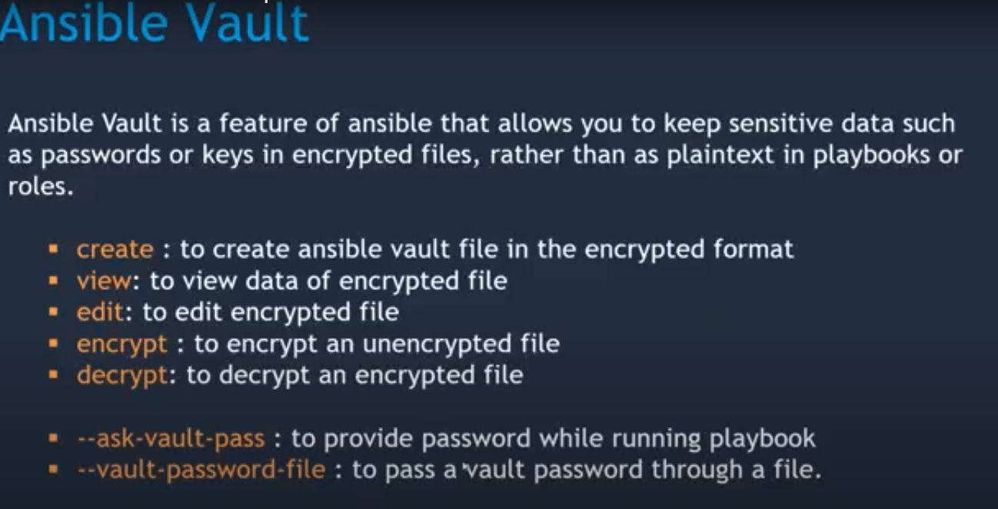

Ansible vault create vault1.yaml

Give the email into the voult file and save it

It will be encrypted

We can see by using the following command

Ansible view vault1.yaml

It will ask passwd and give the passwd then it will open

Now I want to create one user and save it vault

Vi user.yaml

User_rahul

Passwd: ram

Ansiblr vault encrypt user.yml

Vi git_clone

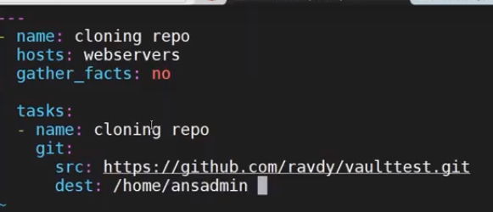

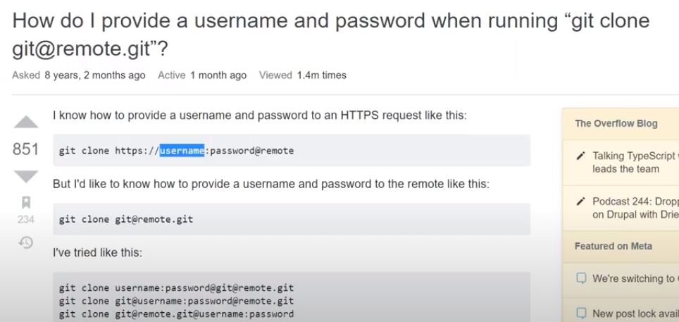

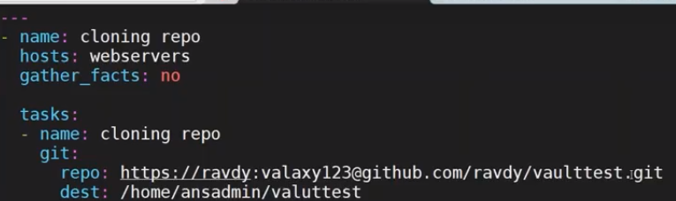

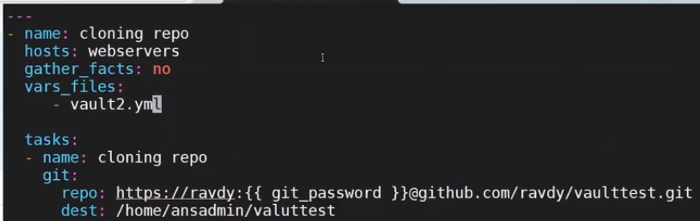

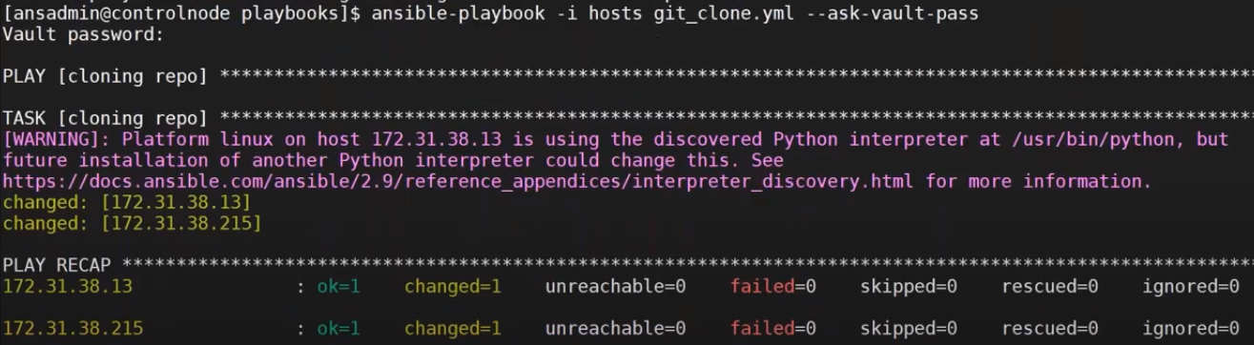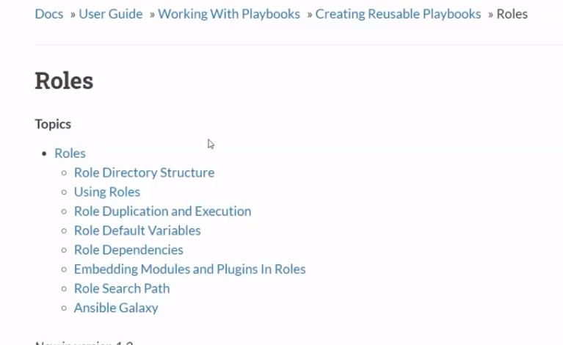

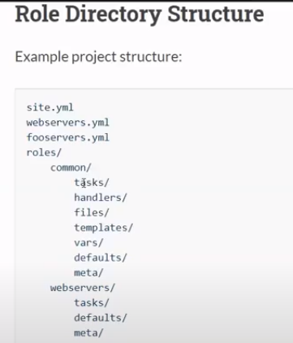

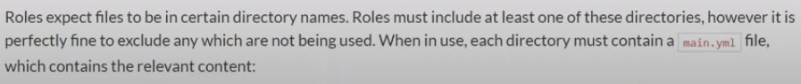

Vi tomcat|_setuo

